Slide 1: Title Slide
Title: Understanding Computer Systems
Subtitle: Definitions, Classifications, and Architecture
Presented by: [Your Name]
Role: [Your Title/Position]

Slide 2: What is a Computer?
Title: The Definition & Core Function
Content:
- Definition: An electronic device that accepts data (input), processes it according to specified rules (process), produces results (output), and stores the results for future use (storage).
- The IPO Cycle:
  - Input: Raw data entered into the system.
  - Process: The computer performs operations on the data.
  - Output: The processed data is presented as useful information.
  - Storage: Data is saved permanently or temporarily.
Speaker Notes: "At its simplest level, a computer is a data processor. It takes raw facts, does the math, and gives you meaningful information. This cycle—Input, Process, Output—is the foundation of all computing."

Slide 3: Classification by Data Handling
Title: Types of Computers: Based on Operation
Content:
- Analog Computers:
  - Work with continuous data (e.g., speedometers, thermometers).
  - Good for measuring physical quantities like voltage or pressure.
- Digital Computers:
  - Work with discrete data (binary digits: 0s and 1s).
  - Used in modern PCs, smartphones, and calculators.
  - High accuracy and speed.
- Hybrid Computers:
  - Combine features of both analog and digital.
  - Example: ICU monitors in hospitals (measure heartbeat analog, display digital numbers).
Speaker Notes: "Most computers we use today are Digital. However, Analog computers are still crucial in engineering and medical fields where measuring continuous waves is necessary."

Slide 4: Classification by Size & Power
Title: Types of Computers: Based on Configuration
Content:
- Supercomputers: The fastest and most expensive. Used for complex calculations like weather forecasting and nuclear simulations.
- Mainframe Computers: Large systems that support hundreds of users simultaneously. Used by banks and airlines for bulk data processing.
- Minicomputers: Mid-range computers, powerful than PCs but smaller than mainframes. Used as small servers.
- Microcomputers: The most common type. Includes Desktops, Laptops, Tablets, and Smartphones.
Speaker Notes: "Think of a Supercomputer as a Formula 1 car—fast and specialized. A Mainframe is like a Bus—carrying many people at once. A Microcomputer is your personal car—designed for individual use."

Slide 5: Components of a Computer System
Title: The Two Main Pillars
Content:
- Hardware:
  - The physical components you can touch and feel.
  - Examples: Monitor, Keyboard, Hard Drive, Chips.
- Software:
  - The set of instructions (code) that tells the hardware what to do.
  - You cannot touch software; it exists digitally.
  - Examples: Windows, MS Word, Google Chrome.
Speaker Notes: "A computer needs both to function. Hardware is the body, and Software is the soul. One is useless without the other."

Slide 6: Hardware - The Central Processing Unit (CPU)
Title: The Brain of the Computer: CPU
Content:
- Role: Executes instructions and controls other parts of the computer.
- Key Parts:
  - ALU (Arithmetic Logic Unit): Performs math ($+, -, *, /$) and logic decisions (Is $A > B$?).
  - CU (Control Unit): Directs the flow of data (traffic cop); tells components how to respond to instructions.
  - Registers: Small, super-fast storage areas inside the CPU for immediate data access.
Speaker Notes: "The CPU is a tiny chip, but it does all the heavy lifting. The Control Unit fetches instructions, and the ALU executes them."

Slide 7: Hardware - Memory & Storage
Title: Primary vs. Secondary Memory
Content:
- Primary Memory (RAM - Random Access Memory):
  - Volatile: Data is lost when the power is turned off.
  - Function: Used to hold data currently being used by the CPU (short-term memory).
- Secondary Storage (Hard Drives/SSD):
  - Non-Volatile: Data remains even without power.
  - Function: Used for long-term storage of files, photos, and the Operating System.
- ROM (Read-Only Memory): Stores startup instructions (BIOS) that cannot be easily changed.
Speaker Notes: "Think of RAM as your desk workspace—it's where you put documents you are working on right now. The Hard Drive is the filing cabinet—where you put things away for safekeeping."

Slide 8: Hardware - Peripherals
Title: Input and Output Devices
Content:
- Input Devices:
  - Hardware used to send data into the computer.
  - Examples: Keyboard, Mouse, Microphone, Scanner, Webcam.
- Output Devices:
  - Hardware that receives data from the computer and displays it to the user.
  - Examples: Monitor (Screen), Printer, Speakers, Projector.
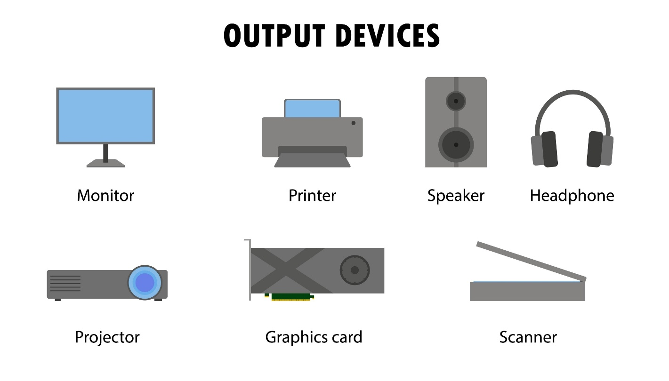
Shutterstock
Speaker Notes: "Peripherals are how we communicate with the machine. Without them, the computer would just be a box processing data silently with no way to show us the result."

Slide 9: Software Components
Title: The Layers of Software
Content:
- System Software:
  - Software designed to run the computer's hardware and application programs.
  - Operating System (OS): The master program (e.g., Windows, macOS, Linux, Android).
  - Device Drivers: Translators that help the OS talk to hardware (e.g., Printer Driver).
- Application Software:
  - Programs designed for the end-user to perform specific tasks.
  - Examples: Web Browsers, Word Processors, Games, Photo Editors.
Speaker Notes: "The Operating System manages the house (the hardware), while Applications are the tools you use inside the house to get work done."

Slide 10: Conclusion
Title: Summary & The Future
Content:
- Recap:
  - Computers process data via the IPO cycle.
  - They range from massive Supercomputers to pocket-sized Microcomputers.
  - They consist of Hardware (CPU, Memory, I/O) and Software (System, Application).
- The Future:
  - Quantum Computing: Exponentially faster processing using quantum mechanics.
  - AI Integration: Computers that learn and adapt rather than just following static instructions.
- Q&A
Speaker Notes: "Computers have evolved from filling entire rooms to fitting in our watches. Understanding their basic components helps us appreciate the technology we rely on every day. Thank you!"

